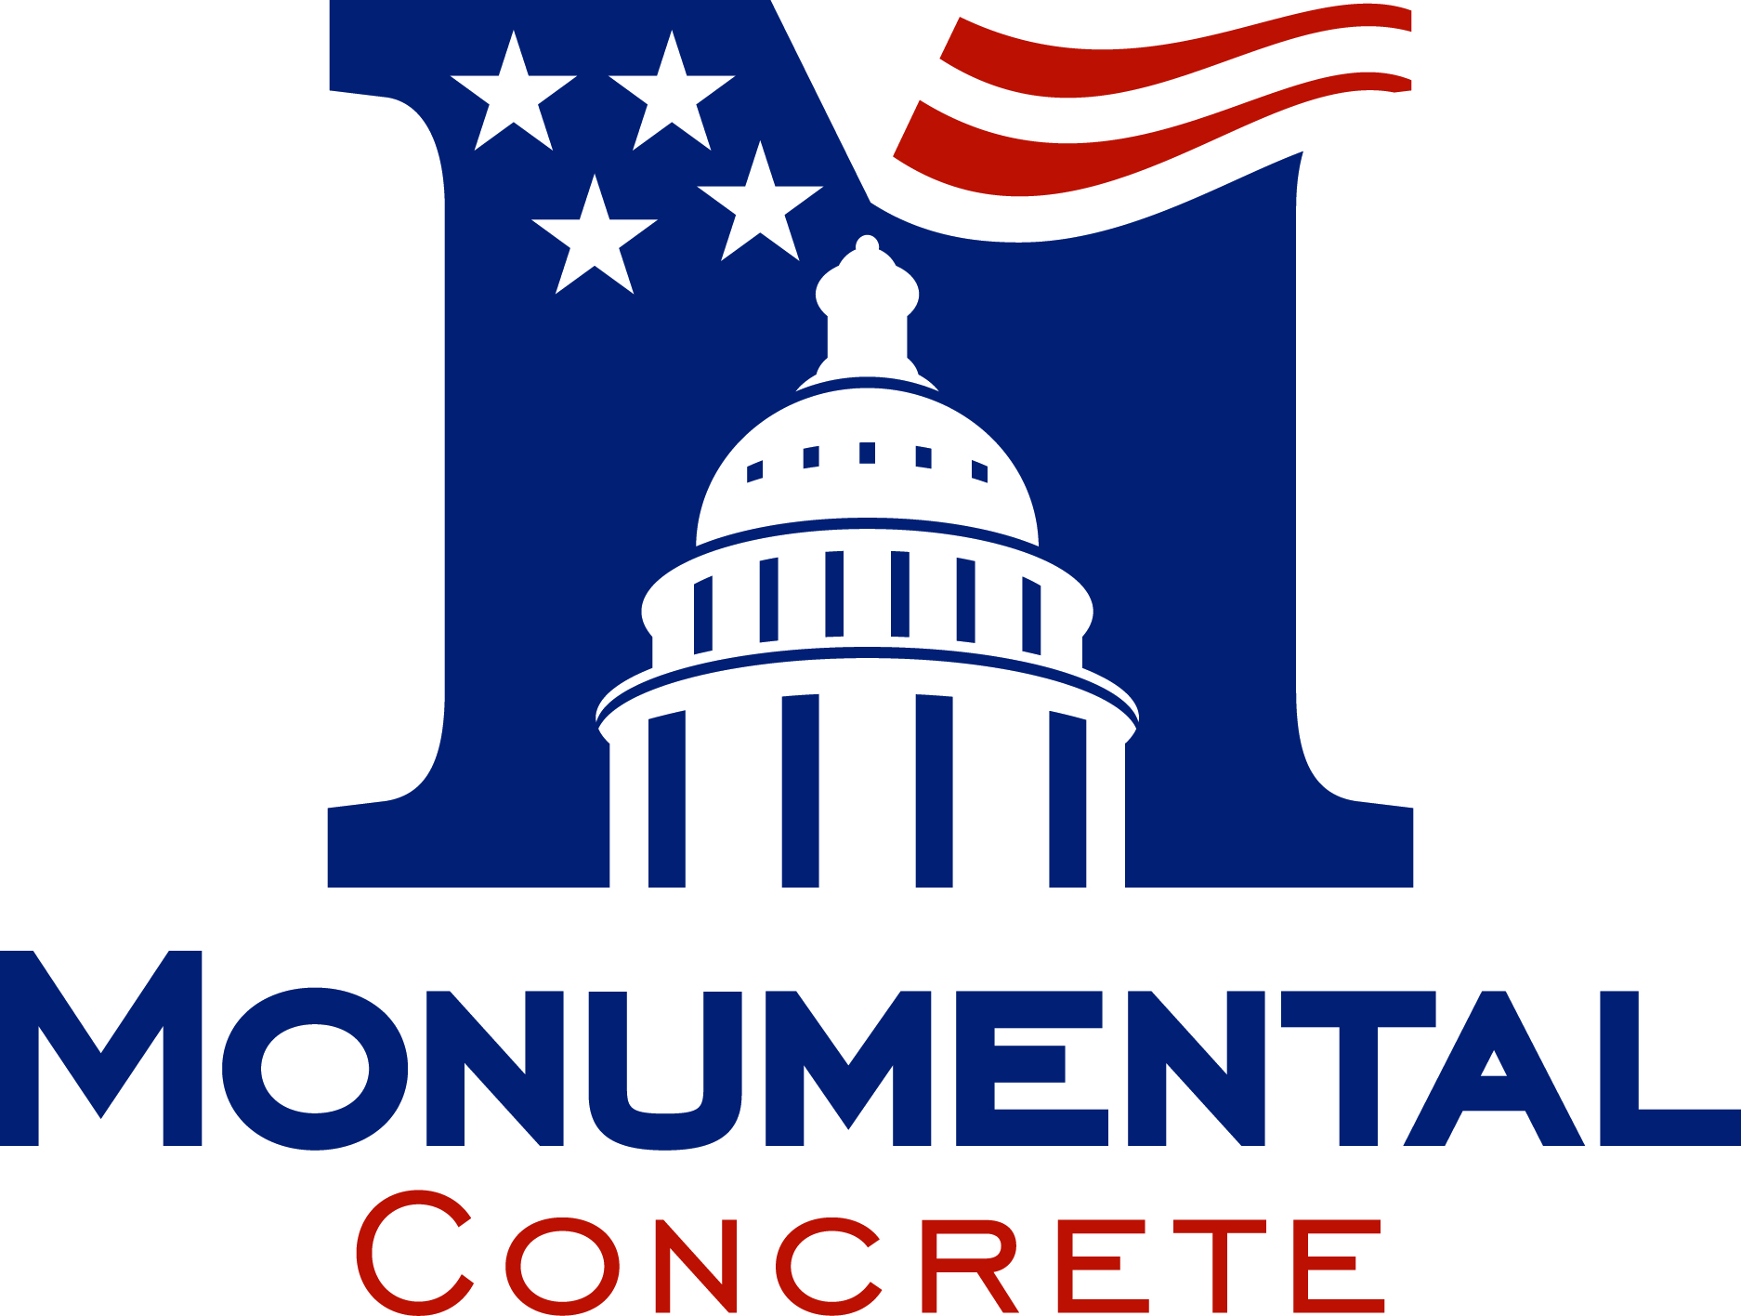

MATERIAL SAFETY DATA SHEET
Monumental Concrete, P.O. Box 548, Waldorf MD 20604
Emergency Phone: 301-932-5021

Revision Date: 01/09/08

1. Product Name: Ready-Mix Concrete

Chemical Family: N/A
Hazardous Classification: N/A

2. Hazardous or Toxic Ingredients: Mix design may dictate the use of admixtures for which the MSDS sheets can be attached. Admixture quantities may vary from 0.01% to 1.69%.

3. Physical Data:
Specific Gravity: Depending on materials, 2.3-2.5

Appearance: Gray Paste, with sand and gravel

4. Fire and Explosion Hazard Data:
Flash Point: N/A
Method Used: N/A
Flammable Limits:
LFL: N/A
UFL: N/A
Extinguishing Media: N/A
Special Fire & Unusual Hazards: N/A

- Health Hazard Data:
Threshold Limit Value Ready-Mix Concrete is delivered as a compound in a semi-liquid state. TLV concerns cement in a dry state with respirable dust.

Acute: Cement as an ingredient in the wet state can dry the skin and cause alkali burns.

Chronic: Concrete dust as from chipping or breaking up hardened concrete can
contain crystalline silica. Long term exposure to crystalline silica can cause
permanent damage to the lungs and lead to the disease known as silicosis.

- Reactivity Data:
Stability: Stable
Incompatibility: N/A
Hazardous Decomposition Products: N/A
Hazardous Polymerization: Will not occur

- Environmental and Disposal Information:
Action to Take for Spills/Leaks: Flush with water
Waste Disposal Method: Customary procedures for construction material waste disposal.

- Precautions for Safe Handling:
No Special Precautions are required except:
- Dust inhalation should be avoided.
2. Skin exposure to wet concrete should be avoided.

- Generally Applicable Control Measures:
- To Reduce Dust: Concrete should be used in the wet state.
- Rubber Boots, gloves, and other personal protective equipment should be worn so as to protect the skin from exposure to wet concrete.

10. Emergency & First Aid Procedures:
If skin or eyes come into contact with wet concrete, flush with clean potable water
as soon as possible.

Updated January 9, 2008

Monumental Concrete
P.O. Box 548
Waldorf, MD 20604
301-932-5000

The information herein is given in good faith. No warranty, expressed or implied, is given regarding the accuracy of these data or the results obtained from the use thereof. Consult Chaney Enterprises Limited Partnership for further information.

